|  |
| --- |
| **A.Y :** 2023-24 **Regulation :** R20  **Subject Name : Design and Analysis Of Algorithm Code :**  **Year & Course: III B.Tech -I Semester**  **Branch :** CSE **Section :** A& B  **Faculty Name :**Mr.T.PRASAD **Designation**: Asst.Professor |

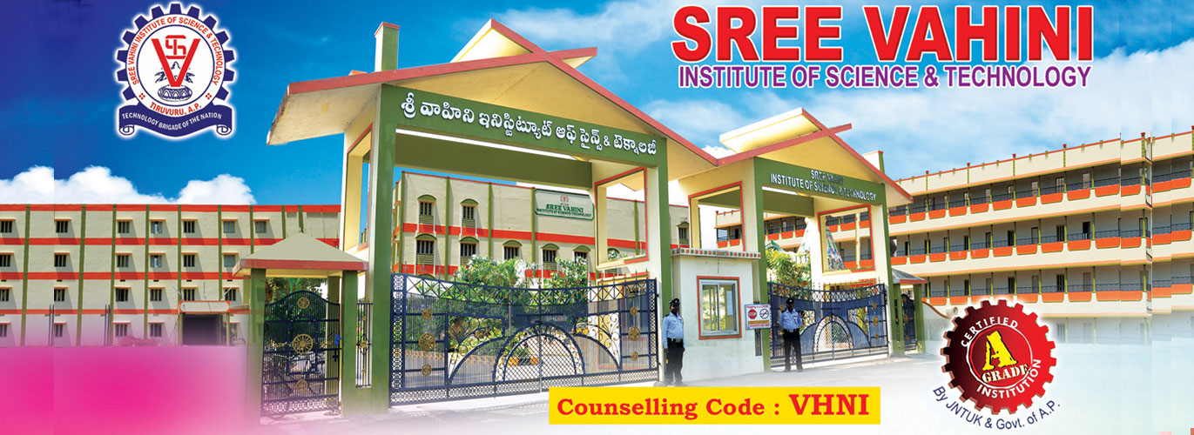

**COURSE FILE**

**COURSE SCHEDULE**

|  |
| --- |
| **A.Y :** 2023-24 **Regulation :** R20  **Subject Name : Design and Analysis Of Algorithm Code :**  **Year & Course: III B.Tech -I Semester**  **Branch :** CSE **Section :** A& B  **Faculty Name :**Mr.T.PRASAD **Designation**: Asst.Professor |

**Expected dates of completion of the Course:**

|  |  |  |  |  |  |
| --- | --- | --- | --- | --- | --- |
| **S.No.** | **Unit No.** | **Title** | **Duration (Dates)** | | **No. of Periods** |
| **From** | **To** |
| **1.** | I | Introduction of DAA | 19-07-2023 | 14-08-2023 | 12 |
| **2.** | II | Divide and Conquer ,The Greedy Method | 16-08-2023 | 31-08-2023 | 13 |
| **3.** | III | Dynamic Programming | 01-09-2023 | 30-09-2023 | 10 |
| **4.** | IV | Backtracking | 01-10-2023 | 17-10-2023 | 12 |
| **5.** | V | NP-Hard and NP-Complete problems | 18-10-2023 | 05-11-2023 | 10 |
| **TOTAL** | | | | | 57 |

**R Remarks (if any): Additional classes may be available which can be used for thorough revision.**

**Faculty Signature HOD**

**Lesson Planner**

|  |
| --- |
| **A.Y :** 2023-24 **Regulation :** R20  **Subject Name : Design and Analysis Of Algorithm Code :**  **Year & Course: III B.Tech -I Semester**  **Branch :** CSE **Section :** A& B  **Faculty Name :**Mr.T.PRASAD **Designation**: Asst.Professor |

**Number of Hours per week: 05**

**Total number of Hours required for completing the course: 61**

|  |  |  |  |  |  |  |
| --- | --- | --- | --- | --- | --- | --- |
| **Sl. No** | **Unit** | **Topic(s) to be covered** | **No of Periods Required** | **Mode of Teaching** | **Text/**  **Reference Books Recommended** | **Actual Date of completion** |
| **1** | **I** | Algorithm Definition | 1 | BB | T1, T2,R1 | 2 |
| **2** | Algorithm Specification | 3 | BB | T1, T2,R1 | 4 |
| **3** | Performance Analysis | 3 | BB | T1, T2,R1 | 4 |
| **4** | Performance measurement | 2 | BB | T1, T2,R3 | 4 |
| **5** | Asymptotic notation | 2 | BB | T1, T2,R1 | 2 |
| **6** | Randomized Algorithms | 1 | BB | T1, T2,R1 | 1 |

|  |  |  |  |  |  |  |
| --- | --- | --- | --- | --- | --- | --- |
| **7** | **II** | Introduction Divide and Conquer | 1 | BB | T1, T2, R2 |  |
| **8** | General Method | 1 | BB | T1, T2, R2 |  |
| **9** | Defective chessboard | 1 | BB | T1, T2, R2 |  |
| **10** | Binary Search | 1 | BB | T1, T2, R3 |  |
| **11** | Finding the maximum and minimum | 1 | BB | T1, T2, R2 |  |
| **12** | Merge sort | 1 | BB | T1, T2, R2 |  |
| **13** | Quick sort | 1 | BB | T1, T2, R3 |  |
| **14** | Introduction The Greedy Method | 1 | BB | T1, T2, R3 |  |
| **15** | The general Method | 1 | BB | T1, T2,R1 |  |
| **16** | Knapsack problem | 1 | LCD, BB | T1, T2, R2 |  |
| **17** | Minimum-cost spanning Trees | 1 | BB | T1, T2, R2 |  |
| **18** | Optimal Merge Patterns | 1 | LCD,BB | T1, T2, R2 |  |
| **19** | Single Source Shortest Paths | 1 | BB | T1, T2, R3 |  |
| **20** | **III** | Introduction Dynamic Programming | 1 | LCD,BB | T1, T2, R2 |  |
| **21** | The general method | 1 | LCD,BB | T1, T2, R2 |  |
| **22** | Multistage graphs | 2 | BB | T1, T2,R1 |  |
| **23** | All pairs-shortest paths | 1 | BB | T1, T2,R1 |  |
| **24** | Optimal Binary search trees, | 1 | BB | T1, T2,R1 |  |
| **25** | 0/1 knapsack | 2 | BB | T1, T2,R1 |  |
| **26** | The traveling salesperson problem | 2 | LCD,BB | T1, T2,R3 |  |
| **27** | **IV** | Backtracking | 1 | BB | T1, T2,R1 |  |
| **28** | The General Method | 1 | BB | T1, T2,R1 |  |
| **29** | The 8-Queens problem | 2 | BB | T1, T2,R1 |  |
| **30** | Sum of subsets | 2 | BB | T1, T2,R1 |  |
| **31** | Graph coloring | 2 | BB | T1, T2,R1 |  |
| **32** | Hamiltonian cycles | 2 | BB | T1, T2,R1 |  |
| **33** | Knapsack problem | 2 | BB | T1, T2,R1 |  |
| **34** | **V** | NP-Hard and NP-Complete problems | 2 | BB | T1, T2,R1 |  |
| **35** | Basic concepts | 2 | LCD,BB | T1, T2,R1 |  |
| **36** | Non-deterministic algorithms | 2 | BB | T1, T2,R1 |  |
| **37** | NP - Hard and NP-Complete classes | 2 | BB | T1, T2,R1 |  |
| **38** | Cook’s theorem. | 2 | BB | T1, T2,R1 |  |

**Faculty Signature HOD**

**Text Books and References**

**TEXT BOOKS:**

**T1:** Ellis Horowitz, SartajSahni, Sanguthevar Rajasekaran, “Fundamentals of Computer   
 Algorithms”,2ndEdition, Universities Press.

**T2:** Introduction to Algorithms Thomas H. Cormen, PHI Learning.

**T3:** Harsh Bhasin, “Algorithms Design & Analysis”, Oxford University Press.

**REFERENCES:**

**R1:** Horowitz E. Sahani S: “Fundamentals of Computer Algorithms”, 2 nd Edition, Galgotia   
 Publications, 2008

**R2:** S. Sridhar, “Design and Analysis of Algorithms”, Oxford University Press.

**Faculty Signature HOD**